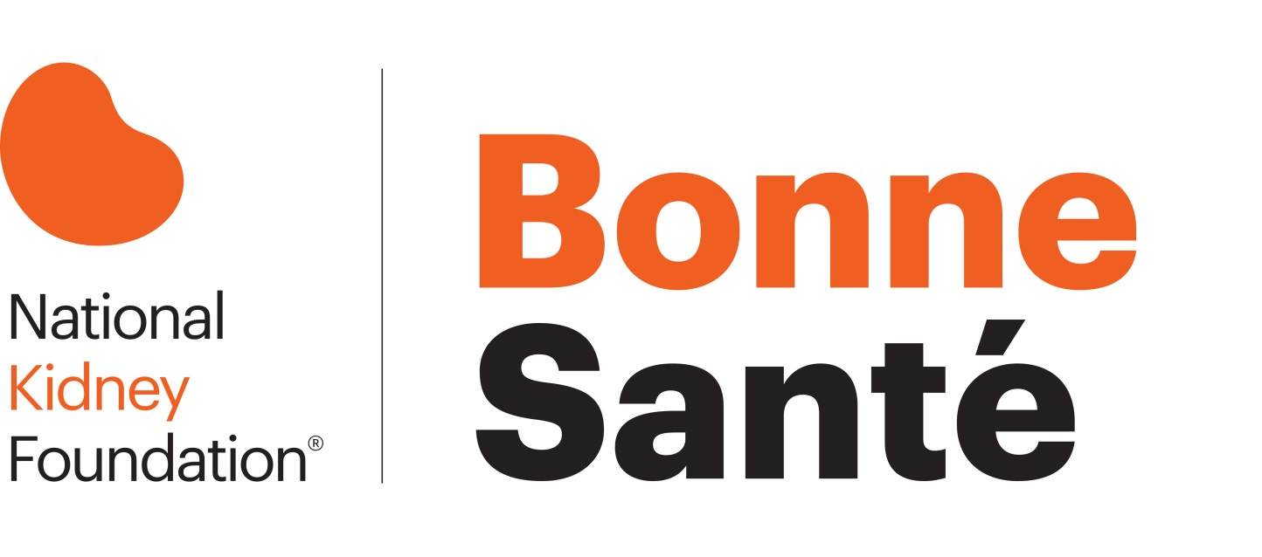

Partnership Opportunities
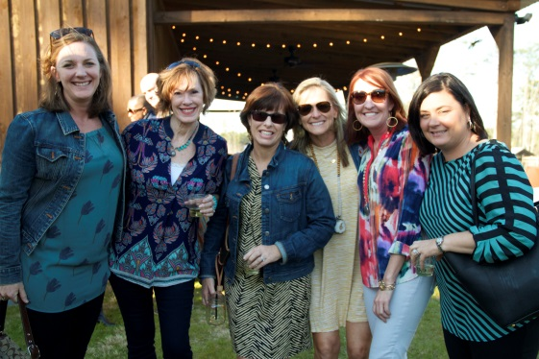
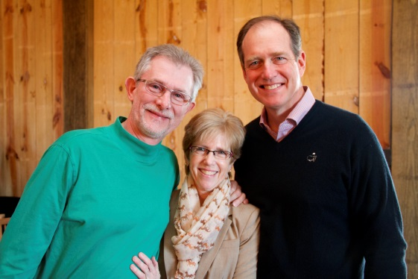
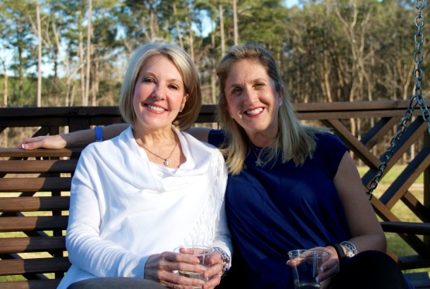

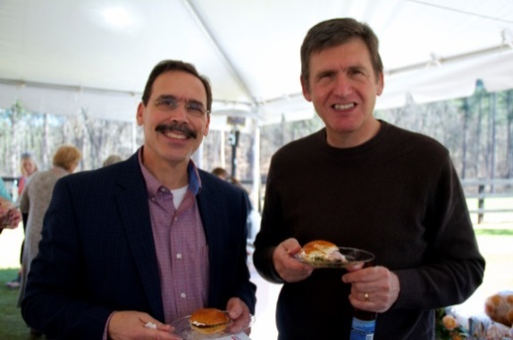
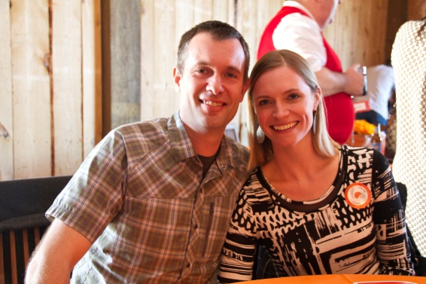
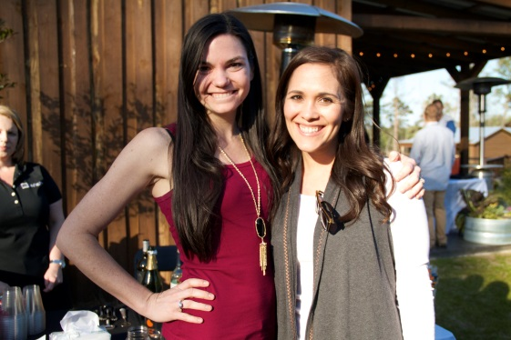

March 10, 2019
Pine Knoll Farms

2019 PARTNERSHIP OPPORTUNITIES
PRESENTING SPONSOR $10,000
One Opportunity Available

REQUESTS OF A PRESENTING SPONSOR

- A minimum donation of $10,000
- Internal promotion of Bonne Santé to employees
- External promotion of Bonne Santé through marketing when applicable

BENEFITS PROVIDED BY THE NATIONAL KIDNEY FOUNDATION

Pre-Event
- Company name cited as Presenting Sponsor throughout 2019 Bonne Santé media promotions and press releases
- Company logo will be included on printed and digital event communications, including:
  - Poster (Approximately 250)
  - Save the date (Approximately 500)
  - Invite (Approximately 500)
  - Bonne Santé webpage
- Company logo cited on NKF serving Alabama, Georgia and Mississippi Facebook page regarding Bonne Santé

Day of Event
- 2 Tables for Bonne Santé event (reserved seating for sixteen guests)
- 2 advertisements in the virtual event program
- 1 Company booth provided at the Bonne Santé venue where information and/or samples may be distributed
- Company logo will be included on event signage
- Verbal recognition during the Bonne Santé ceremony

Post Event
- Recognition on the NKF serving Alabama, Georgia and Mississippi’s website, indicating post-event results
- Company cited in Bonne Santé post-event press release

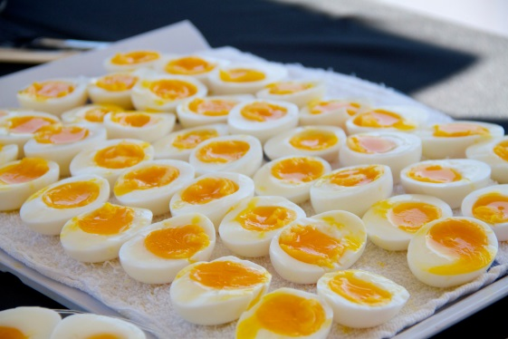
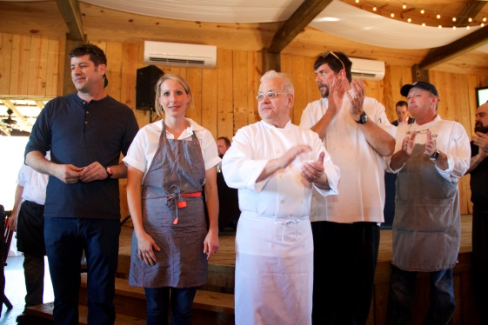
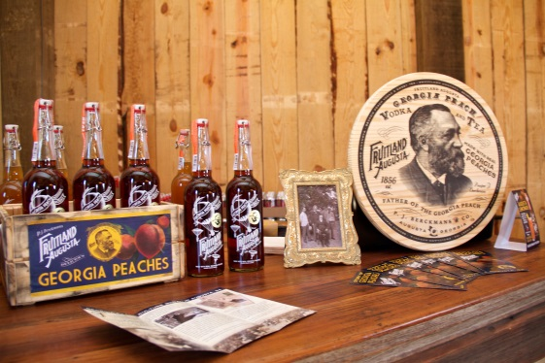
2019 PARTNERSHIP OPPORTUNITIES

GOURMET SPONSOR $7,500

- Company name cited as Gourmet Sponsor throughout 2019 Bonne Santé media promotions and press releases
- Company logo will be included on printed and digital event communications, including:
  - Poster (Approximately 250)
  - Save the date (Approximately 500)
  - Invite (Approximately 500)
  - Bonne Santé webpage
- Company logo cited on NKF serving Alabama, Georgia and Mississippi Facebook page regarding Bonne Santé
- 1 Table for Bonne Santé event (reserved seating for eight guests)
- 1 advertisement in the virtual event program
- Company logo will be included on event signage
- Verbal recognition during the Bonne Santé ceremony

CHEF SPONSOR $5,000

- Company name cited as Chef Sponsor throughout 2019 Bonne Santé media promotions and press releases
- Company logo will be included on printed and digital event communications, including:
  - Poster (Approximately 250)
  - Bonne Santé webpage
- Company logo cited on NKF serving Alabama, Georgia and Mississippi Facebook page regarding Bonne Santé

- 1 Group ticket to Bonne Santé event (entry for four guests)
- 1 advertisement in the virtual event program
- Company logo will be included on event signage

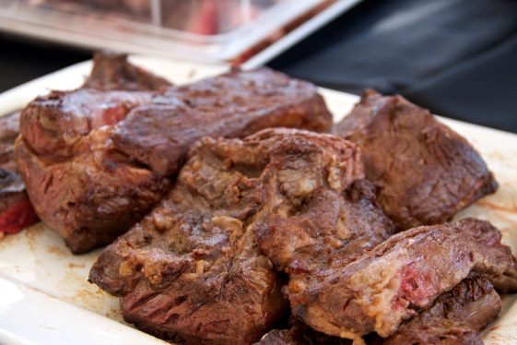
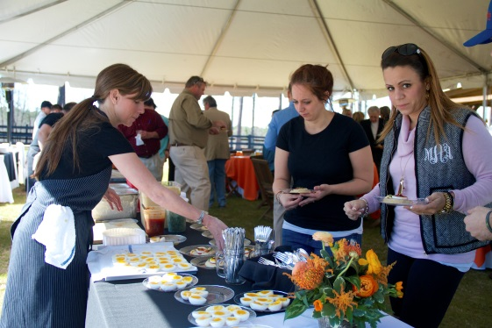
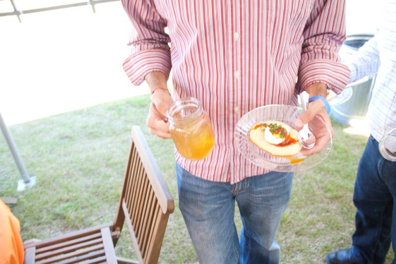

2019 PARTNERSHIP OPPORTUNITIES

A LA CARTE SPONSOR $2,500

- Company name cited as A La Carte Sponsor throughout 2019 Bonne Santé media promotions and press releases
- Company logo will be included on Bonne Santé webpage
- Company logo cited on NKF serving Alabama, Georgia and Mississippi Facebook page regarding Bonne Santé
- 2 Individual tickets to Bonne Santé event
- Company logo will be included on event signage

HEALTH TENT SPONSOR $1,000

- Vendor table with company logo in the Health Tent
- Opportunity to provide literature and information to all attendees
- Company logo cited on NKF serving Alabama, Georgia and Mississippi Facebook page
- Includes 2 individual tickets to Bonne Sante event

Table Purchase - $700 (Entry for 8)

Group Ticket - $350 (Entry for 4)

Individual Ticket - $100

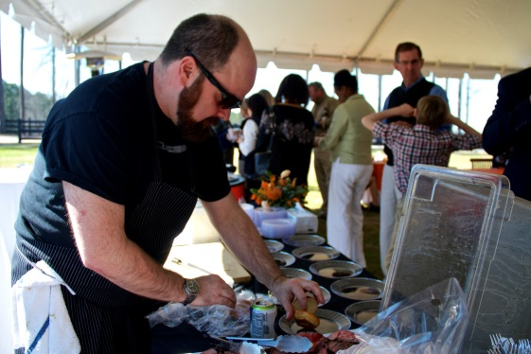
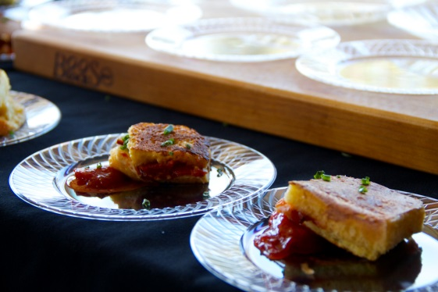
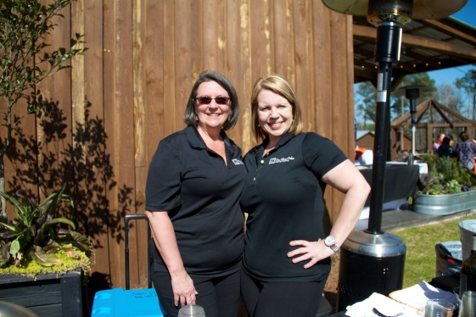

ADDITIONAL PARTNERSHIP OPPORTUNITIES

