
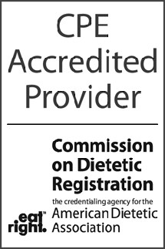
CPEs Awarded

Level

Activity Title:

Participant Name:

Date: ____________

Location: _____
30 East 33rd Street ●New York, NY 10016 ● 800.622.9010 ● www.kidney.org
Continuing Professional Education
Certificate of Attendance
CDR Accredited Provider Number: NK111

CDR Accredited Provider Signature
Bina George-Figueroa, MS, CCMEP
Director, Continuing Medical Education

