Required Information for Promotional Material for
Council CE Activities

Accreditation Statements (depending on Councils)

Nurse and Dialysis Technician

The National Kidney Foundation is an approved provider of continuing nursing education by the New York State Nurses Association, an accredited approver by the American Nurses Credentialing Center’s Commission on Accreditation.
It has been assigned Provider code7QPLGU-PRV-09.

(number of hours) contact hours will be awarded.

Dietitian
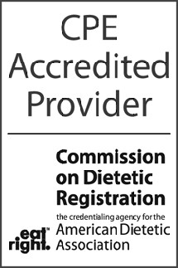
The National Kidney Foundation is a Continuing Professional Education (CPE) Accredited Provider with the Commission on Dietetic Registration
(CDR). Registered dietitians (RDs) and dietetic technicians, registered (DTRs) will receive xx continuing professional education units (CPEUs) for completion of this program/material.

Social Worker

The National Kidney Foundation Council of Nephrology Social Workers, Provider #1014, is approved as a provider for social work continuing education by the Association of Social Work Boards (ASWB) www.aswb.org, through the Approved Continuing Education (ACE) program. The National Kidney Foundation Council of Nephrology Social Workers maintains responsibility for the program.
Social workers participating in this course will receive (insert number of credits) continuing education clock hours. Licensed social workers should contact their individual jurisdiction to review current continuing education requirements for licensure renewal.

Disclosure Statements

Declaration of Disclosure: It is the policy of the National Kidney Foundation (NKF) to ensure balance, independence, objectivity, and scientific rigor in all CME/CE activities. Any individual who has control over CME content is required to disclose to learners prior to the activity any relevant financial relationships) they may have with commercial interests supporting this activity or whose products or devices are discussed in this activity. If, on the basis of information disclosed, a perceived conflict exists, resolution will be achieved based on NKF's Disclosure and Conflict of Interest policy.

Unlabeled/Investigational Use Declaration: During their presentations, faculty may discuss an unlabeled use or an investigational use not approved for a commercial product. Each faculty member is required to disclose this information to the audience when referring to an unlabeled or investigational use.

Disclaimer
The faculty and the National Kidney Foundation do not recommend the use of any pharmaceutical, diagnostic test, or device outside of the labeled indications as approved by the FDA. Please refer to the official prescribing information for each product for approved indications, contraindications, and warnings.

