Vascular Access Guideline Figures

Figure 2.1: Hazard Ration for Mortality with AVF or AVG versus Catheter among Incident HD Patients
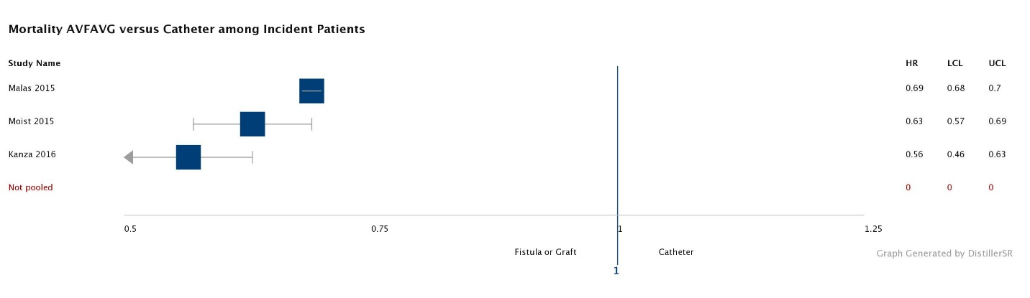
When HRs were reported as Catheter vs AVF/AVG, ratios were inverted for consistency within display. Data were not pooled but are presented here for display only. Plot was made using DistillerSR Forest Plot Generator from Evidence Partners.

Figure 2.2 ESKD Life-Plan Case Examples
Figure 3.1 Placement of femoral vein CVC
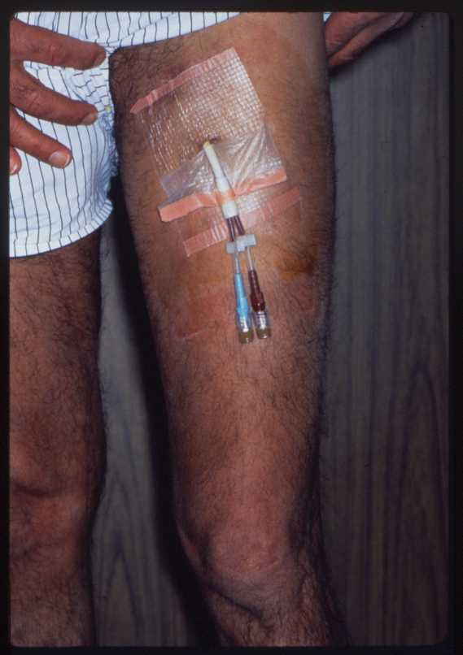

Figure 11.1 Button Hole Infection
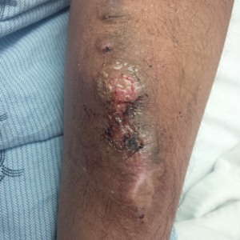

Figure 11.2 The pathogenesis of biofilm formation
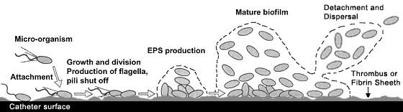

Figure 17.1: Suggested classification for aneurysm/pseudoaneurysm documentation
- Stable vs. Unstable
- Shape of the AVF aneurysm – Valenti Classification
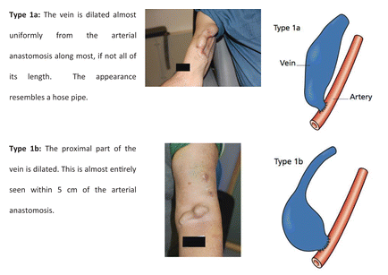
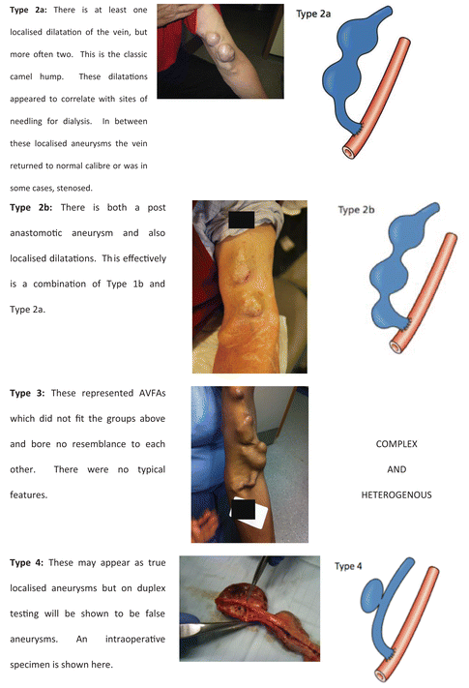

- Pseudoaneurysm of AVG
- Megafistulas

Figure 18.1: Surgical treatment of Steal Syndrome
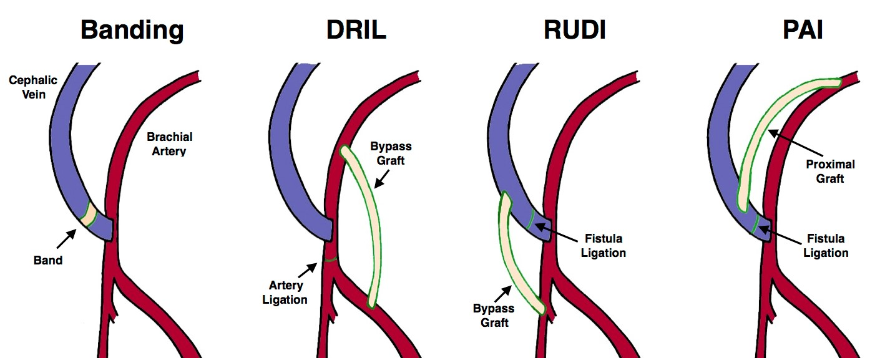

The following management strategies for steal syndrome are for a patient with a brachiocephalic AVF, as follows:
DRIL – a distal revascularization and interval ligation (DRIL) procedure. Note the autogenous or synthetic bypass graft and the ligature on the brachial artery immediately proximal to the distal anastomosis for brachial-brachial bypass

RUDI – Revision using distal inflow. Note that the brachial artery anastomosis to the brachial-cephalic access was ligated. A bypass graft is placed from the radial artery to the proximal aspect of original access

PAI – proximalization of the arterial inflow . Note that the autogenous access has been dissembled and a bypass graft is inserted between the more proximal brachial artery and the proximal segment of the original AVF

Figure 19.1 Seroma
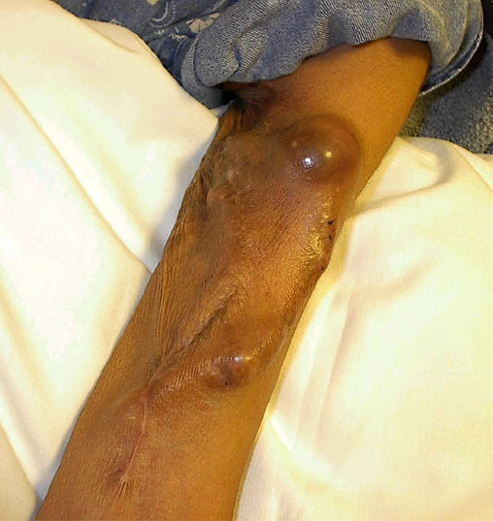

Figure 24.1 Catheter Infection-free Survival
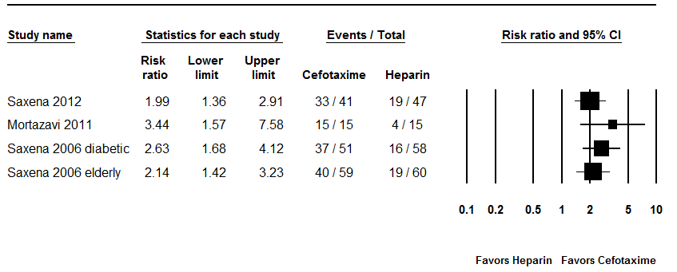

Figure 25.1 Algorithm: Treatment for CVC Infection

(file)

Figure 26.1 Physical Findings of Central Venous Stenosis

